Woolsocks – The Money App Expands Financial Ecosystem with Acquisition of Loyalty App OK
Luzern, Switzerland &ndash; Woolsocks AG, founded by the Dutch creators of online broker DEGIRO, has announced the acquisition of the loyalty app OK, marking another significant milestone in its strategic expansion across Europe. This acquisition, following Woolsocks' recent purchase of Data &amp; Insights company Hiiper, strengthens Woolsocks&rsquo;s position as a leading financial super-app, enhancing its money management and saving tools.

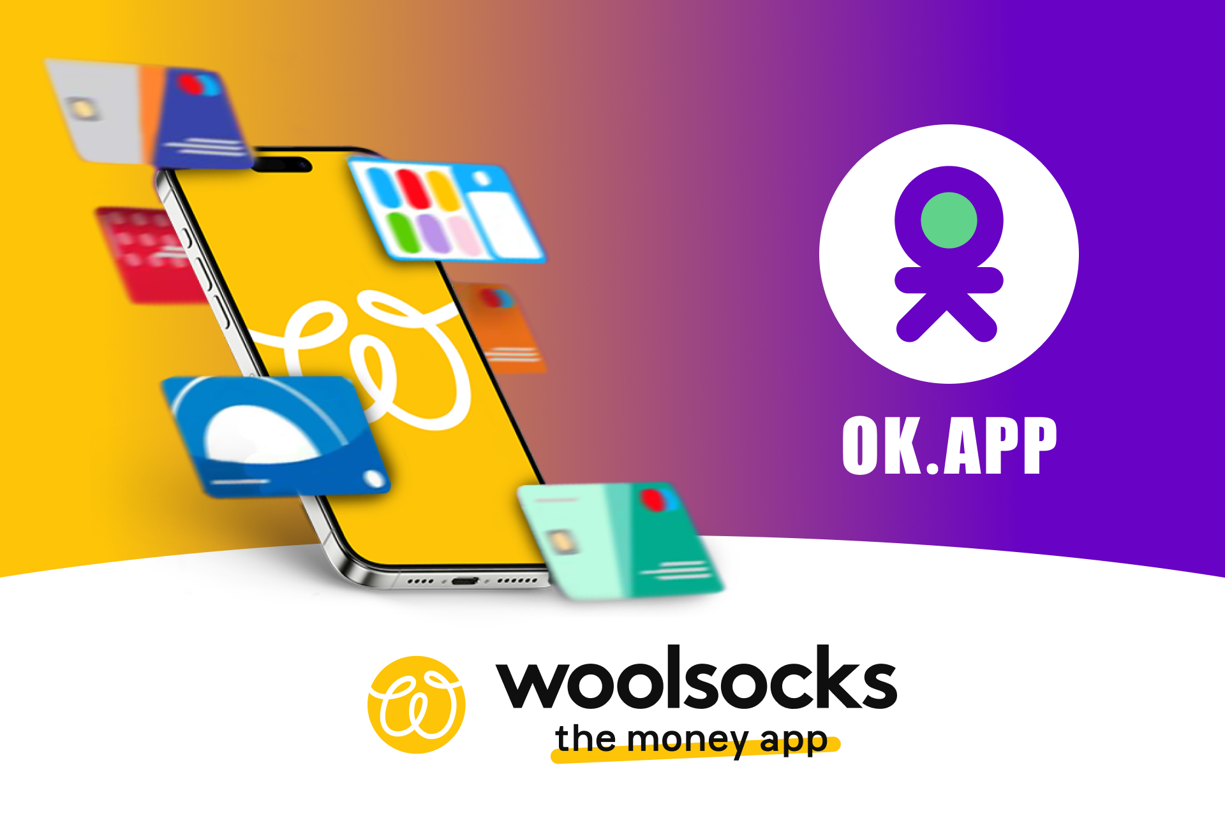

Boosting savings and convenience for millions of users across Europe
The OK-app will remain fully operational for all existing users, ensuring they continue to benefit from its existing features while Woolsocks adds new functionalities. Brands will also gain access to enhanced services, including advanced data insights and targeting made possible through Woolsocks' open banking technology. These tools will allow brands to manage campaigns more effectively, offering deeper customer engagement and maximizing marketing potential.
By integrating OK's features into the Woolsocks app, the company will provide over 5 million users in the Netherlands, Belgium, Germany, France, Italy, Spain, and Ireland with new value-added services. The OK-app enabels users to store and manage loyalty cards, gift cards, and coupons from major retailers like IKEA, Decathlon, and MediaMarkt, all in one place.
“The addition of OK-app to our ecosystem expands our user base and provides tools for users and brands to maximize savings and marketing efficiency,” states Carlos Valenzuela, Group CEO of Woolsocks AG. “Users can continue using the OK-app as before, while brands will also have the ability to plan targeted campaigns.”
Leveraging open banking
technology for retailers
By leveraging open banking, Woolsocks allows users to save seamlessly through loyalty programs, while offering retailers deep insights into customer behavior that extends beyond their internal loyalty programs, physical stores and online shops.
“With Woolsocks and the OK-app, we provide retailers with a powerful, data-driven marketing channel,” Valenzuela added. “These insights help brands optimize promotions, boost sales, and allocate their budgets more efficiently. Not only can we measure the real-time effectiveness of campaigns within our apps, but we also track the impact of other channels such as online marketing, out-of-home, TV, and print, enabling brands to refine their overall marketing strategies."
About Woolsocks AG’s Strategic Acquisitions

Woolsocks AG continues to make bold moves in the FinTech space, cementing its position as a key player and leading innovator in financial apps. For more details, visit
Sillicon Channels

Over: Woolsocks - The Money App
Woolsocks is a FinTech with over 5 million active users across 7 European markets.<br />
<br />
Through innovative open banking technology, Woolsocks enables brands to optimize promotions, gain unique insights on consumer behavior, and boost revenue with hyper-personalized, data-driven marketing and loyalty campaigns.<br />
<br />
Key app features for customers:<br />
- Smart Money Management: Personal finance tools, subscription management, commission-free investing, and tailored savings and investment plans.<br />
- Rewards &amp; Savings: Personalized shopping rebates, loyalty programs, and rewards on vouchers and gift cards.<br />
- Payments &amp; Transfers: Fast and secure remittances, Buy Now, Pay Later, and innovative fundraising solutions.

Newsroom
View the full press release including more photos and videos in our Newsroom.
View the full press release
View all previous press releases

Contact information
Name: Zeno van de Ven
Email: zvandeven@woolsocks.eu
Phone: +31 6 52773998

