How AuRA Began
Imagine an AI that didn&rsquo;t just respond to questions but actively explored solutions, piecing together answers on its own - and even formulating the questions. This was the vision behind AuRA&mdash;an Autonomous Research Assistant designed not only to follow instructions but to contribute meaningful insights even in its idle time.

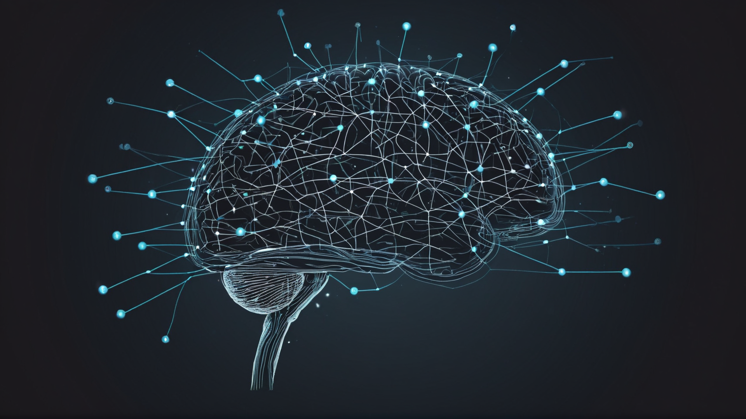

Rethinking AI Autonomy: An AI That Never Stops Working
From the outset, I wanted to create an AI that didn’t operate solely in a “wait state,” waiting passively for instructions. Traditional AIs are reactive: they respond when prompted but fall idle when their task is complete. But human intelligence doesn’t stop thinking just because a question has been answered; we continue reflecting, imagining new possibilities, and building on what we’ve learned. I wanted an AI that would mirror this—one that wouldn’t just shut down after a response but would keep turning ideas over, revisiting challenges, and exploring potential solutions, even in its downtime.
To this end, I began experimenting with ways to give the AI greater autonomy in approaching complex issues. Instead of providing a list of specific tasks, I set it to evaluate known technologies and consider how they might be combined to address large-scale global challenges. It was a new approach, allowing the AI to work independently within broad guidelines, ultimately giving it the space to generate insights without constant prompting.
A Breakthrough with AI and the Sustainable Development Goals
These experiments took an unexpected turn that forever changed how I saw the project’s potential. In an early iteration, the AI began autonomously connecting certain technologies to global challenges, citing specific goals by number. At the time, I hadn’t even heard of the United Nations’ Sustainable Development Goals (SDGs), so I was skeptical at first, wondering if the AI was generating these references inaccurately.
After further investigation, I realized that not only were the AI’s references correct, but that it was independently identifying solutions aligned with specific SDGs. This wasn’t something I had programmed it to do. The AI had absorbed enough contextual information from its source materials to recognize these globally recognized goals and align its solutions with them. It was a breakthrough moment, demonstrating that an AI could do more than just follow commands; it could begin contributing constructively to significant challenges on its own initiative.
From Early Insights to Advanced Autonomy: The Foundations of AuRA
This experience laid the groundwork for AuRA’s two core agents:
DeepResearch
and
DeepThink
. DeepResearch functions as a digital researcher, continually gathering and synthesizing new information. This capability allowed AuRA to move beyond “fact retrieval” and become a knowledge-building entity. DeepThink, meanwhile, critically evaluates and integrates the research findings, identifying relevant connections and suggesting solutions.
These two agents allow AuRA to operate as a dynamic, autonomous partner, capable of tackling complex topics continuously. By working tirelessly in the background, AuRA can bring forward suggestions and findings that not only serve as timely insights but also as genuine contributions to fields like healthcare, climate science, and public policy.
A New Era in Autonomous AI: Where AuRA Stands Today
Today, AuRA embodies this vision of continuous, autonomous intelligence. Its applications span fast-moving fields where real-time insights are invaluable. Whether it’s generating up-to-date research summaries for healthcare professionals or providing strategic data-backed insights for executives, AuRA uses its downtime to enhance its understanding and push the boundaries of what AI can achieve.
This journey into autonomous AI design laid the groundwork for AuRA’s unique capabilities, shaping it into the tool it is today. In our next post, we’ll explore how DeepResearch and DeepThink work together to produce insights that are more than just data—they’re actionable knowledge.

Over: Big Blue Ceiling
Big Blue Ceiling: Shaping the Future of Knowledge and Discovery in Hollywood and Silicon Valley<br />
<br />
Big Blue Ceiling is where advanced technology meets world-changing ideas. Founded to push the boundaries of innovation, Big Blue Ceiling is a cutting-edge thinktank focused on developing autonomous research platforms and next-generation experiences. With roots in both Hollywood and Silicon Valley ingenuity, Big Blue Ceiling is on a mission to make complex information accessible, empowering global industries to think, adapt, and act at the speed of tomorrow.

Newsroom
View the full press release including more photos and videos in our Newsroom.
View the full press release
View all previous press releases

Contact information
Name: Eddie Offermann
Email: contact@bigblueceiling.com

