10 events you can't miss at Upstream this year
Rotterdam - Upstream 2021 will present you with the opportunity to build meaningful connections and create positive impact at the 5-day event hosted in Rotterdam. Upstream's team has shortlisted the top 10 events so that you can make the most of your experience this year.

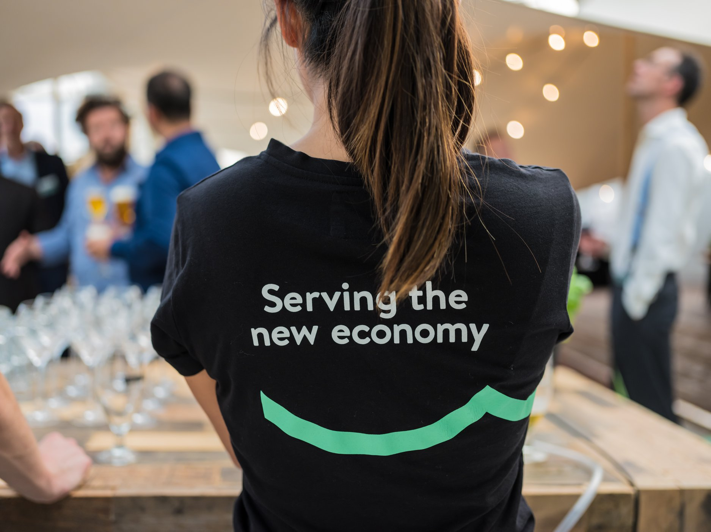

- Official Opening (20/9): join us as we speak with Mayor Aboutaleb and Techleap envoy Constantijn van Oranje on the importance of scaling innovative technologies.
- Daily Talkshow (20-24/9): with speakers including Dirk de Bruijn (Swapfiets), Paul Polman (former CEO Unilever), Kelly Weekers (Moonshot Coaching), Daan Roosegaarde and Heleen Dura-van Oord.
- Exclusive CEO dinner (20/9): connecting the founders of our region's fastest growing scale-ups.
- Re-invent Yourself (21/9): hear from professionals who happily pivoted their career and get some valuable tips to get that scale-up job that suits you like a glove.
- Startup & Scale-up Career Fair (21/9): explore scale-up careers and experience first hand what it means to help build an innovative and fast-growing company.
- Investor Readiness (22/9): gain insight into how your company can grow successfully and concrete tools to achieve a positive financing trajectory.
- Startup Roulette (22/9): match with three carefully selected investors during this online speed dating event for selected startups and investors.
- Meet The Buyer (23/9): carefully curated matchmaking between startups/scale-ups and innovative corporates to facilitate corporate-startup collaboration.
- Crash Course Scaling Internationally (23/9): a 1.5 hour deep-dive into international expansion.
- F*ckup Nights (24/9): learn from the F*ckups of founders willing to share their stories with us.
Join Upstream offline or online and get access to capital, new markets and talent via workshops, events and sessions hosted by the co-creation partners. Sign up for these events via
https://www.upstreamfestival.com/

Over: Upstream
Interview met een van de bekende sprekers? Dat kan aangevraagd worden via rob@uprotterdam.com of per telefoon 06 17 188 946 <br />
<br />
Perskaarten zijn beschikbaar en kunnen aangevraagd worden via: rob@uprotterdam.com. De opening vindt plaatst op 20 september <br />
<br />
Andere zaken nodig? Uiteraard staan wij voor u klaar!

Newsroom
View the full press release including more photos and videos in our Newsroom.
View the full press release
View all previous press releases

Contact information
Name: Rob Lagendijk
Function: Public relations manager
Email: rob@uprotterdam.com
Phone: 0617188946

