Michiel Muller, Paul Polman, Kelly Weekers and many more top entrepreneurs present at Upstream
Rotterdam &ndash; From 20 to 24 September, Upstream will take place in a remarkable space: a circular craft beer brewery called The Stadshaven Brouwerij. The brewery, located in the Rotterdam Makers District, transforms into the place where startup and scale-up founders, investors, students, policy makers and bold corporates come together to make a positive impact in the world.

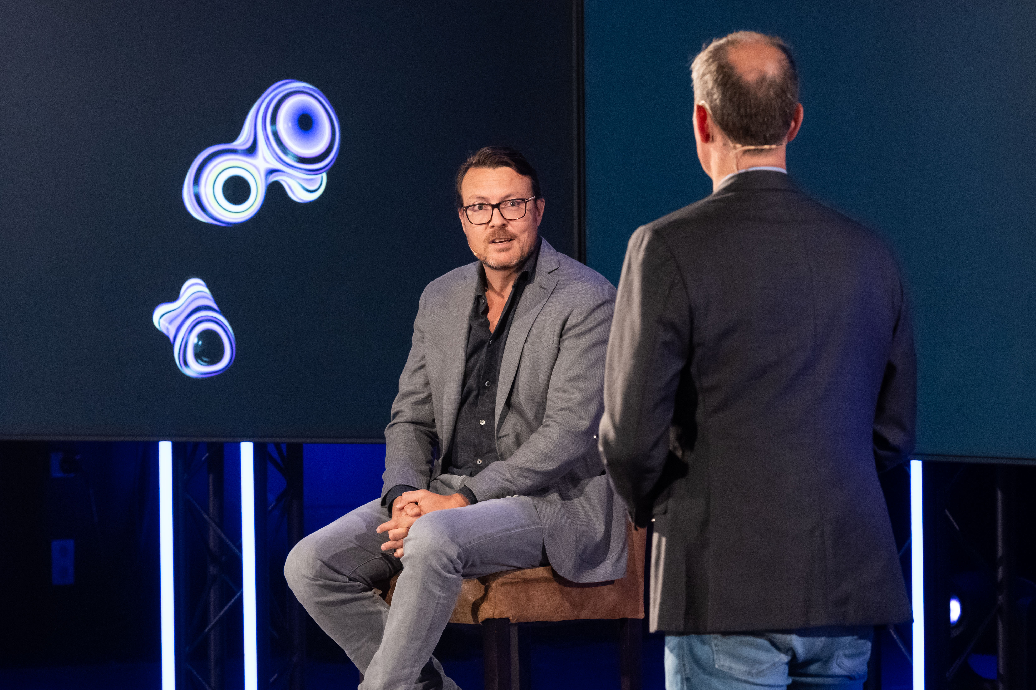

Upstream’s rapidly growing network provides access to an international ecosystem of talent, funding, markets and exposure opportunities. Changemakers from different backgrounds and industries come together to elevate the innovation capacity of the greater Rotterdam region and highlight its position as a fast evolving tech environment for businesses to grow nationally and internationally.
Together we can make it work. Paul Polman, one of the speakers during Upstream Festival: “
The only way we can solve these crises and heal our planet is if we come together in a spirit of radical collaboration – or what I call a Net Positive vision – business, governments, NGOs, civil society, and especially the younger generations driving towards to the broader system changes we need.”
Upstream’s Co-Creation Partners are setting up an on- and offline programming of keynotes, talk shows, round tables, workshops, webinars and network events. 5 days, 30+ speakers, 40+ co-creation partners, 40+ events. Mayor Ahmed Aboutaleb will open the event on Monday. Every day various events will take place around different themes:
- Tuesday | Talent Day
- Wednesday | Capital Day
- Thursday | Market Day
- Friday | Growth Day
Kelly Weekers will share her learnings about how to become a successful growth entrepreneur on the daily Upstream Festival talk show on Friday.
“
To be a successful entrepreneur, mindset is key. The growth journey is nothing more than obstacle management. Ups and downs, opinions of others, it’s the name of the game. If you can focus on your own vision and strategy the results will follow.”
Join Upstream offline or online and get access to capital, new markets and talent via workshops, events and sessions hosted by the co-creation partners:
https://www.upstreamfestival.com/

Over: Upstream
Interview met een van de bekende sprekers? Dat kan aangevraagd worden via rob@uprotterdam.com of per telefoon 06 17 188 946 <br />
<br />
Perskaarten zijn beschikbaar en kunnen aangevraagd worden via: rob@uprotterdam.com. De opening vindt plaatst op 20 september <br />
<br />
Andere zaken nodig? Uiteraard staan wij voor u klaar!

Newsroom
View the full press release including more photos and videos in our Newsroom.
View the full press release
View all previous press releases

Contact information
Name: Rob Lagendijk
Function: Public relations manager
Email: rob@uprotterdam.com
Phone: 0617188946

